Machine Learning Implementation on Construction Approval System

**SUBMITTED TO :-**

**Praxis Business School**

**Submitted By – Team :6**

**Pawan thakur**

**Ishaan nirmal**

**soumyadip ghatak**

**rahul lamge**

**shayantam das**

2021

**Executive summary**

The reason why there is a long wait in building permit processing is because application usually passes through utilities, development engineering, planning and issues related to land use. The timeline from filing for an approval to getting the permit varies differently from places to places and the process requires you to be present manually which becomes a worry for many. Larger projects and commercial projects may take longer time than small-scale project. That is simply due to variation in complexity and scale of the particular project.

The permit is than required to be passed by the licensed person and there is also the option that allows the property owner to complete all the work themselves. The permit is than required to be passed by the licensed person and there is also the option that allows the property owner to complete all the work themselves.

Based on a survey by World bank India ranks 6th worst in getting construction permit and 183 out of 189 countries as per the reports issued. This is due to excessive paper work and long procedures commonly known as Red Tapism.

So when done manually illegal approvals become a common theme. Instead the process should be transparent and can be improved and tailored to meet particular needs using machine learning techniques.

**Business domain & problem**

The construction industry is an important part of the country's economy. Construction is an important sector that contributes greatly to the economic growth of a nation. It also creates investment opportunities across various related sectors and vital to the achievement of national socio-economic objectives. Construction contributes to economic development by satisfying some of the basic objectives of development including output generation, employment creation, and income generation, and re-distribution. It also plays a major role in satisfying basic physical and social needs, including the production of shelter, infrastructure, and consumer goods. Construction’s requirements for goods and services from other industries are considerable; the development of the construction industry therefore stimulates these ancillary industries, thus encouraging further economic growth.

In India Construction has accounted for around 40 per cent of the development investment during the past 50 years. Around 16 per cent of the nation's working population depends on construction for its livelihood. The Indian construction industry employs over 30 million people and creates assets worth over ₹ 200 billion.

One of the challenges faced by the construction Industry is getting the Permit for Constructing houses, Structures, Buildings. A construction permit, also known as a building permit is a licence which needs to be sought from authorities for any new construction or adding on top of pre-existing structures the authorities always ensure that new construction is meeting the state and local building codes by conducting inspections during construction and completion phases. However, if any developer fails to procure the permit or meet the requirements, the construction will be deemed illegal and significant fines and penalties will be imposed which can further lead to demolition. The absolute cost of seeking the construction permit might not be significantly high but the delays add to incremental costs which impact the overall project. Interest costs, re-design costs, opportunity costs, construction cost, etc. all inadvertently impact the overall development cost of the project.

It is an unending process which spans anywhere from 12 to 24 months. In addition, the revenue department and its issues also delay the entire process of planning and approvals. The process of approvals are sequential in nature. Approvals from Municipal Corporation, Water supply Board, Electricity Board, State Pollution Control Board, Environmental clearance certificate if built up area is 20,000 sq/m , Fire department if there are more than 5 floors in a building etc.

The first and foremost challenge is the lack of coordination between all departments that delays the approval process beyond expected timelines. Further, sudden changes in planning bye-laws add to the chaos. It has been observed that if there have been amendments in the bye-laws post procuring the NOC, developers have to again make changes in the planning and re-apply for the NOC from the scratch. This not only delays the project commencement but, in many cases, alters the entire project plan mid-way as well.

Experts’ share that most of the cities in the world follow a simple system for construction permits and the guidelines are clearly spelt out. This ensures there is no dependence on the department and the architect designing the development is solely responsible for ensuring its correctness and conformity to guidelines. In order to ensure smooth flow of the process, real estate developers are seeking the introduction of single window clearance as part of the Real Estate Bill as the system is systematic and time-bound. With the real estate sector contributing significantly towards country’s GDP and overall economic health, hence, strong measures and initiatives are the need of the hour.

India was ranked 185 among 190 nations surveyed on the parameter of getting a construction permit. The World Bank had then pointed out that India had not managed to shift online its construction permits system.India is the 6th worst when it comes to getting construction permit.The process needs to be streamlined and online. One registration mechanism is need of the hour and data science and Machine Learning can play a vital role in implementing the same

**Problem quantification for machine learning procedures**

The problem that we have tried to solve was to build a machine learning model which takes in certain parameters which are necessary for any construction project to be approved then the model analyzed those parameters and then gave its decision as YES/NO .

The machine learning model is first trained on some historical dataset which enables the machine to learn so that when it encounters a new parameter then the model can analyze the parameter and then can give the decision of approval based upon its findings .

Some of the features which we considered for solving this problem are as follows :-

1. Floor to ceiling height
2. Natural grade of floor
3. Outdoor emergency exit
4. Opening height
5. Opening width
6. Opening area
7. Area of landing
8. Drainage system present
9. Window cover signage
10. Approved / disapproved

The model will be trained on the historical dataset on the basis of the above mentioned parameters then after that when the model encounters any new parameter for analysis then the model can analyze it on its own and then it can give the decision .

**Sample dataset with justification and reference**

|  |  |  |  |  |  |  |  |  |  |  |
| --- | --- | --- | --- | --- | --- | --- | --- | --- | --- | --- |
| **FLOOR TO CEILING HEIGHT** | **NATURAL GRADE OF FLOOR** | **OUTDOOR EMERGENCY EXIT** | **OPENING HEIGHT** | **OPENING WIDTH** | **OPENING AREA** | **AREA OF LANDING** | **DRAINAGE SYSTEM PRESENT** |  | **WINDOW COVER SIGNAGE** | **APPROVED?** |
| 7.9 | 1.9 | FALSE | 23.8 | 20.8 | 5 | 9.5 | TRUE |  | TRUE | NO |
| 7.5 | 1.1 | TRUE | 25.2 | 21.3 | 4.9 | 9.1 | TRUE |  | FALSE | NO |
| 7 | 1.3 | TRUE | 25.4 | 21.5 | 4.9 | 10.2 | FALSE |  | FALSE | NO |
| 7.1 | 0.6 | FALSE | 25.6 | 21.1 | 5.1 | 8.8 | TRUE |  | TRUE | NO |
| 7.2 | 0.4 | TRUE | 25.9 | 20.4 | 5.6 | 8.9 | FALSE |  | FALSE | NO |
| 7.2 | 0.5 | TRUE | 24.9 | 19.7 | 5.3 | 9.5 | TRUE |  | TRUE | YES |
| 8.6 | 1.4 | FALSE | 25.5 | 21.5 | 5.1 | 10.6 | TRUE |  | TRUE | NO |

Here we have taken an arbitrary dataset based upon certain parameters these parameters are basically the necessary features which are required for the approval / dis-approval of any construction permit the machine learning model will be trained on these parameters only so that if any new parameter is to be analyzed in the future by the model then it will b e able to do it on its own .

**Solution methodology & evaluation**

Our solution provides the construction approval authority a list of applications with highest probability of getting approved. This will save time by reviewing the most probable applications first in-turn cutting time for approval which takes months.

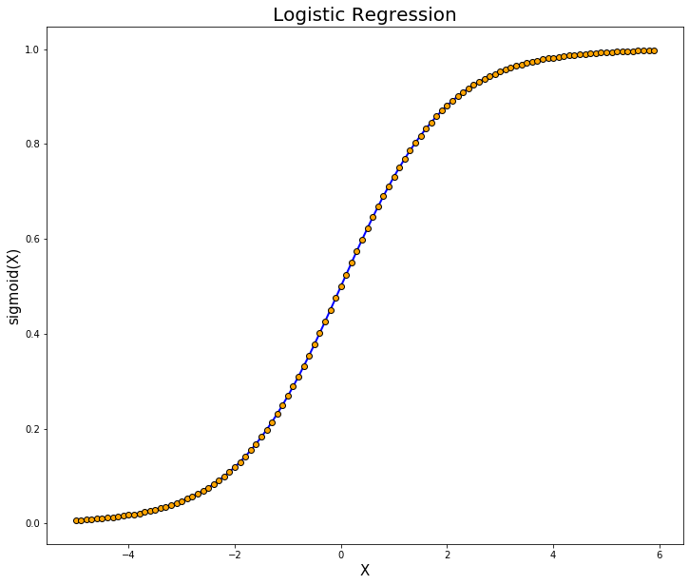

The objective of this model is to assign a probability of getting the application approved. So we will be using Logistic Regression Model. We will separate the independent variables (X) and dependent variable (Y). Both variables will be broken down into subsets using sklearn.train_test_split.

The logistic regression coefficients are the coefficients b0, b1, b2, ... bk of the regression equation where X1 to Xk are independent variables.

**logit(p)=b0+b1X1+b2X2+b3X3+...+bkXk**

Using the equation to find probability of dependent variable:

**p=1/1+e−logit(p)**

The cost function we will use to evaluate model’s error is: 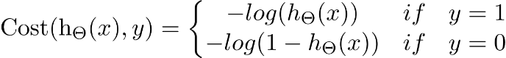

**Architectre of our proposed model**

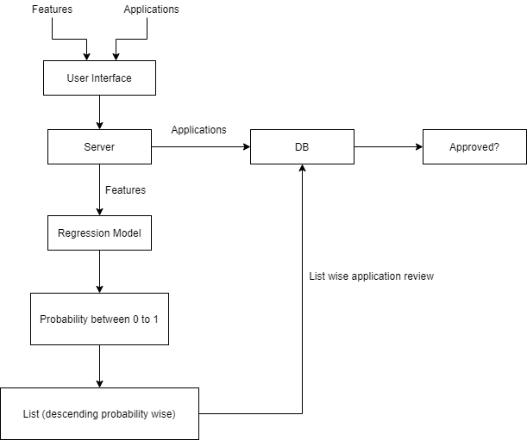

**Possible business impact of the solution**

The business impact of an efficient construction approval system extends well beyond the economic activity of the construction activity itself. In particular, there is considerable economic activity associated with construction whether it be rent, utilities, maintenance or renovations. In addition, the availability of housing allows the population to grow – one of the key drivers of economic growth.

1. **REDUCTION IN DELAYS**

The reduction of delays of the construction approval process from proposal to completion can achieve an increase in housing supply and investment. This is an incredibly important factor as continued growth in housing is required to meet the demand of demographic growth and help reduce housing shortage and affordability issues. Any additional housing that can support population growth and its associated economic growth can play a key role in recovering from the current economic crisis. Even moderate improvements can have a significant effect.

1. **FOLLOWING ECONOMIC TRENDS**

When dealing with a downturn in the economic environment, small construction companies have the advantage of being lean and agile enough to proactively respond to macroeconomic changes by shifting their services towards projects in high demand. This means an efficient and responsive approval system is extremely essential for the survivability of these companies.

1. **TRANSPARENCY**

Construction regulations are one of the critical factors for many companies when deciding where to establish their businesses. When an approval system is transparent, there is minimal interference in the form of any bureaucratic red tape which can lead to faster approval process.

`**Next Steps**

After we have studied all the parameters & the impact which they will be having , now we can design the model accordingly based upon the parameters mentioned which will result in ease of doing work & will give faster results as when compared to manual functions .

**References**

1. <https://www.wikipedia.org/>
2. https://www.analyticsvidhya.com/blog/2021/03/logistic-regression/